How Simple and Easy-to-Use checkout designs on Mobile Interface can be used to increase Mobile conversion rates

Dr. North

Kennesaw State University, Department of CS

User Interface Engineering, CS 4712, Section 01

Enrique Penaloza

December 07, 2015

Table Of Contents

------------------------------------------------------------------------------------------------------------

Abstract………………………………………………….……………………………….3

Introduction…………...……..………………………...……………..………………….3

Model used in the Project/ Methods. ……………...……..…………………………..4

Table of Results…………………………………..…………………………………….5

Conclusion and Comments……………………….………………………………..….7

References. …………………..………………....…………………..………………….7

**Abstract**

This article will reflect on how simple and Easy-to-use checkout designs increase Mobile conversion psychology. Using these necessary display properties it contributes and motivates the mobile owner on fulfilling the checkout process completely. The mobile checkout user interface needs to display an attrive page set-up with relevant content that will generate quicker mobile checkouts and increase mobile conversion rate. Mobile conversion rate relates to the impact on consumer shopping experience and decision-making under mobile devices.

**Introduction**

With an effective User-Interface (UI), mobile purchases can follow customers anywhere they go with their phone. This is by the costumed development the user had arranging their apps and widgets. The phone delivers the company’s product universally; it can sell towards older adult users, children users, users with disabilities, and any different diversity that possess and are familiar with the simple functions of their phone.

The smartphone delivers the purchase to the owner’s convenience. Jose, for demonstration, can watch a NFL football game enjoying the New York Giant vs. Green Bay on a Thursday Night lying on top of his couch. His friend Adrian, for demonstration, just finish seeing a Papa Johns commercial and asks Jose if he wanted to share a pizza. Because Jose is conferrable lying on his couch, he would decline the offer because he simply didn’t want to get up and walk for his laptop; or his Internet Browser is so filthy he declines of having one. He instead pulls out his phone and browse for any specials under their app, or under their mobile browser website, and agree on their agreed choosing. Tapping the selective information needed, his order has been placed and he didn’t need to get out of his lying position. Dominos changed the whole Pizza User Interface where the user, at their own convenience, can text a pizza emoji to Dominos and create an EASYORDER and have Dominos reply with a CONFIRM order with the total. Dominos has saved the User time on listing their personal information and later decide they no longer want the pizza.

Because of social media (e.g. Twitter), remote webcasting (e.g. YouTube), and remote connection (e.g. Google Chrome), the user usually has their smartphone near by. This is the time to capitalize and use that convenience of a smartphone, but without an easy checkout station to close the deal, you will have the customer lose control and walk away. Having an attractive page set-up with relevant content will generate quicker mobile checkout time to guarantee more conversion success rates in Mobile Checkout.

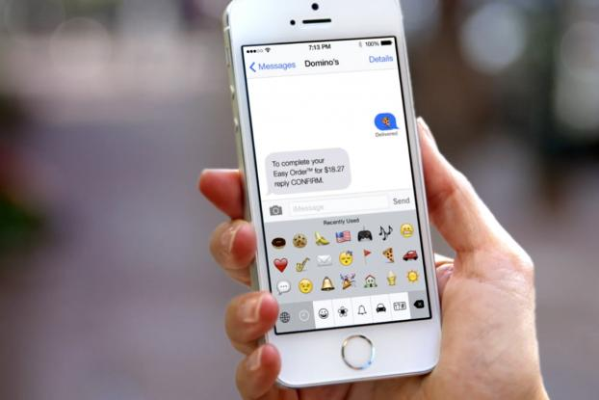

**Model used in the project/ Method**

When the customer has gone and decided on paying for their items and processed to the checkout station on their phone, whether its Android, Apple, or Windows, the checkout station has to fulfill these requirements: Attractive page set-up, Quicker Mobile checkouts, and Include the most relevant content. Focusing on these three requirements will guarantee more conversion success rates in mobile checkouts.

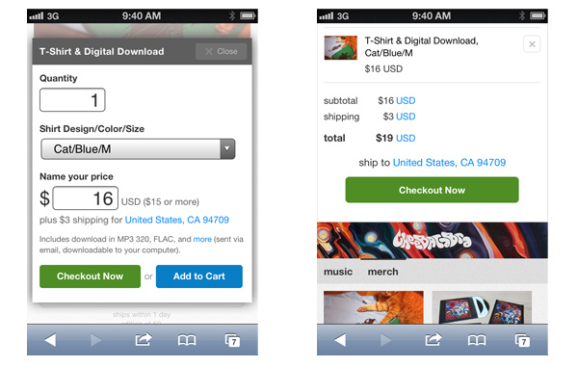

There is a connection between the color and meaning that influences the decision making of a user. Green correlates the mood of “Go”. Just like a traffic light, it associates a positive conclusion in the customer mind to go ahead with the next step. Have everything needed in front of the view of the user that they need to fill out. Have the customer in control. Don’t let the user search the interface if anything is missing. This brings the user unmotivated to continue the sale and leave the purchase altogether. If they have missed a section, direct them after they tapped “next”. Bring into light a red indicator on the missing information so the user can continue the purchase.



Demonstrating a quicker mobile checkout system, allow the customer to view a checkout interface with a simple form that has the customer fill out only the necessary information. This includes the name, address, total, and payment information. Do not include unnecessary information like any of their personal information. Conducting big data database algorithms can retrieve all that information. When focusing on quicker mobile checkouts, it also means loading pages faster. Including more images on your checkout screen increases the wait time on loading up the screen. You need to create an urgency atmosphere that brings in the customer to buy an item before a set time period.

There are some checkout interfaces that bring in too much information on the checkout page. The general rule for smartphones and tablets is the more content, the fewer sales. The layout needs to adapt to the limited screen size and show the most important information visible above the fold. The fold is the imaginary line at the bottom of the page the interface user sees without scrolling. Anything under the fold is only visible with scrolling (Baldassarre). Instead of converting the horizontal layout to a vertical layout and list all content below each other, allow the user to scroll just enough to learn more about the product without giving the impression of an endless scroll; include a button to bring the user back to the top so they don’t have to scroll all the way back up.

**4. Table of results**

Gokhan Karaatli and his team investigated mobile services’ impact on consumer shopping experience and consumer decision-making. The understanding of the mobile services’ impact of different stages of the consumer decision-making process can help marketers to develop marketing strategies that target consumers at different stages of the process. The team categorized the process levels into 5 stages respectfully: Need Recognition, Information Search, Evaluation of Alternatives, Purchase, and Post Purchase Behaviors (Karaatli). Needing Recognition stage is the ability to receive and access information anytime and anyplace. This follows the example of store email promotions. It is the marketing message of the email to act as external cues that help customers to recognize a need, triggering a decision-making process that might result in a purchase. Information Search, in most cases, involve in the customer searching for information. Mobile information search allows the access of information to all types of products and store related information on the mobile Internet; information search allows the access of previous searches stored under the cache of the mobile user. The unique benefit a mobile information search offers is the ability to search information at the user’s convenience and time shared on their smartphone. Evaluation of Alternatives compare the product alternatives, especially on products the user has no relate knowledge too. The shopper can examine or try an item in store and initiate a search for similar items available online or in alternative stores by entering the product information or simply by scanning the item. Purchase is the stage on checkout and payment experience at the point-of-purchase. This stage has been improved by paying the item quickly, easily, and safely. It has improved in the introduction of innovation on purchasing an item by scanning the fingerprint protected mobile device, which can work as a digital wallet, allowing the purchaser to complete the entire transaction at once. Mobile devices can be used as digital wallets. The consumer can make payments by transferring the funds electronically, use electronic coupons, exchange store, membership, and credit card information, and keep electronic receipts of transactions (Karaatli). Post-Purchase is the stage on the beliefs and attitudes of others that can help the customers’ purchase decisions from their own personal experience. With mobile services, it has the potential to improve the quality of a buyer’s purchase decision and can help consumers feel more confident with their purchase decisions.

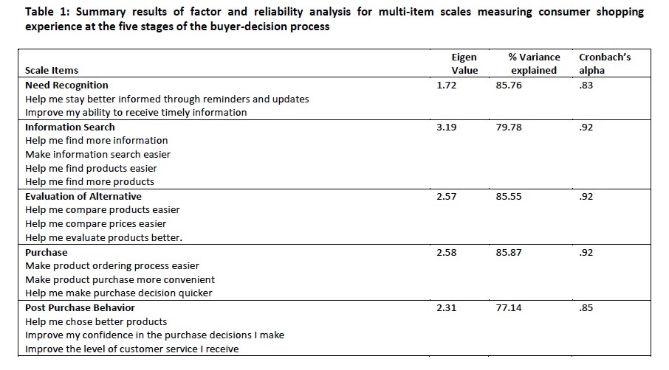

The study, under Karaatli team, conducted twenty-three items to measure consumers’ beliefs on mobile services ability to improve consumer experience at different stages of the consumer decision-making process as well as overall shopping experience. Participants were asked to report mobile services’ impact on various aspects of their shopping experience when compared to a shopping experience with no access to mobile services. They were asked to report their level of agreement or disagreement with 23 statements using 5-point Likert scale. These twenty-three items were used to develop the multi-item scales measuring consumer-shopping experience at different stages of the consumer decision-making process. Table above presents a summary results from these analysis and the resulting multi-item scales (Karaatli).

**5. Comments and conclusions**

For any starter who wants to shop with their phone, mostly adults, there is a concern or fear on the risk of their information being stolen in the process. The best way on dealing with the concern is to advertise to the customer that the site is well protected by website’s security checkout service. You want to advertise the safety feature at an extent where the security feature isn’t overly displayed populating the whole site because that triggers the customer weary on the site being a scam. Advertise the safety feature only at the checkout to give the user the direct connection that their typed information is secured before they second-guess if the site is safe to begin the purchase.

Currently more than 4 billion mobile subscriptions in the world and the total number of smartphone users expected to surpass 1.6 billion users worldwide, the mobile environment offers convenience and flexibility of accessing and sharing information beyond any other communication medium. If it is going to save time, effort, and money, mobile services can motivate a consumer to start the buying process at any time of their comfort.

**References**:

Agrebi, S., & Jallais, J. (2015). Explain the intention to use smartphones for mobile shopping. *Journal Of Retailing And Consumer Services*, *22*16-23. doi:10.1016/j.jretconser.2014.09.003

Baldassarre, Rocco. (2014). 10 Tweaks That Instantly Increase Mobile Conversion Rates. Retrieved from

<http://www.entrepreneur.com/article/240797>

Diamond, Ethan (Photographer). (2012, August 20). The Bandcamp Blog [digital image] Retrieved from <http://blog.bandcamp.com/2012/08/20/every-bandcamp-site-is-now-an-awesome-mobile-site/>

Eastman, J. K., Iyer, R., Liao-Troth, S., Williams, D. F., & Griffin, M. (2014). The Role of Involvement on Millennials' Mobile Technology Behaviors: The Moderating Impact of Status Consumption, Innovation, and Opinion Leadership. *Journal Of Marketing Theory & Practice*, *22*(4), 455. doi:10.2753/MTP1069-6679220407

Karaatli, G., Jun, M., & Suntornpithug, N. (2010). INVESTIGATING MOBILE SERVICES' IMPACT ON CONSUMER SHOPPING EXPERIENCE AND CONSUMER DECISION-MAKING. *International Journal Of Mobile Marketing*, *5*(2), 75-86.

Porter, Crispin. & Bogusky (Photographer). (2015, June 15). Creative-online.com [digital image]. Retrieved from <http://techcrunch.com/2012/03/08/clover-raises-5-8m-from-andreessen-horowitz-launches-as-a-one-click-mobile-payments-platform/>

Rao, Leena. (2012, March 8). Techcrunch.com [digital image]. Retrieved from <http://techcrunch.com/2012/03/08/clover-raises-5-8m-from-andreessen-horowitz-launches-as-a-one-click-mobile-payments-platform/>

Schiff, L. Jennifer. (2015). 12 ways to improve the customer experience for online shoppers. Retrieved from

<http://www.cio.com/article/2914780/e-commerce/12-ways-to-improve-the-customer-experience-for-online-shoppers.html?page=2>

Shneiderman, Ben, & Planisant, Catherine. (2010). DESIGNING THE USER INTERFACE: Strategies for Effective Human-Computer Interaction. College Park, University of Maryland: Addison-Wesley

Shuiqing, Y., Yuangao, C., & June, W.(2015). UNDERSTANDING CONSUMERS' WEB-MOBILE SHOPPING EXTENSION BEHAVIOR: A TRUST TRANSFER PERSPECTIVE. *Journal Of Computer Information Systems*, *55*(2), 78.

Yang, K., & Kim, H. (2012). Mobile shopping motivation: an application of multiple discriminant analysis. *International Journal Of Retail & Distribution Management*, *40*(10), 778. doi:10.1108/09590551211263182